Service Instructions

This document contains the information on the Vincent Printing web service. The service is not currently available to the public and the url is subject to change based on where we deploy it.

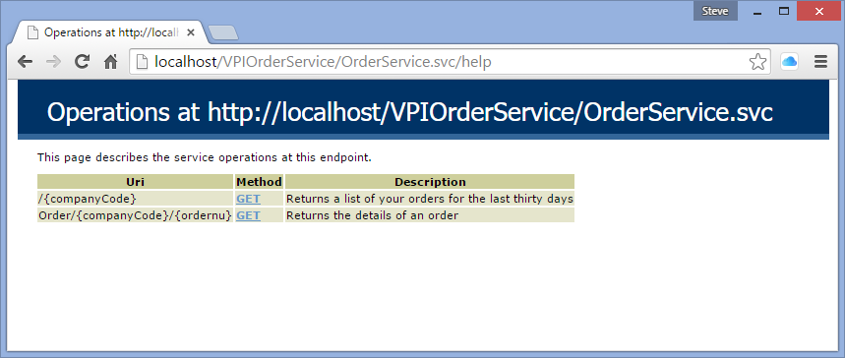

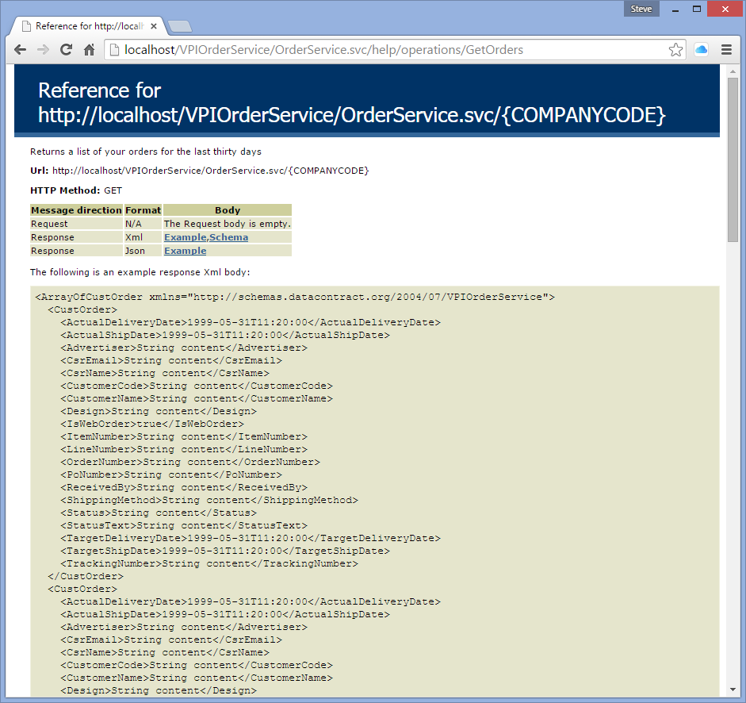

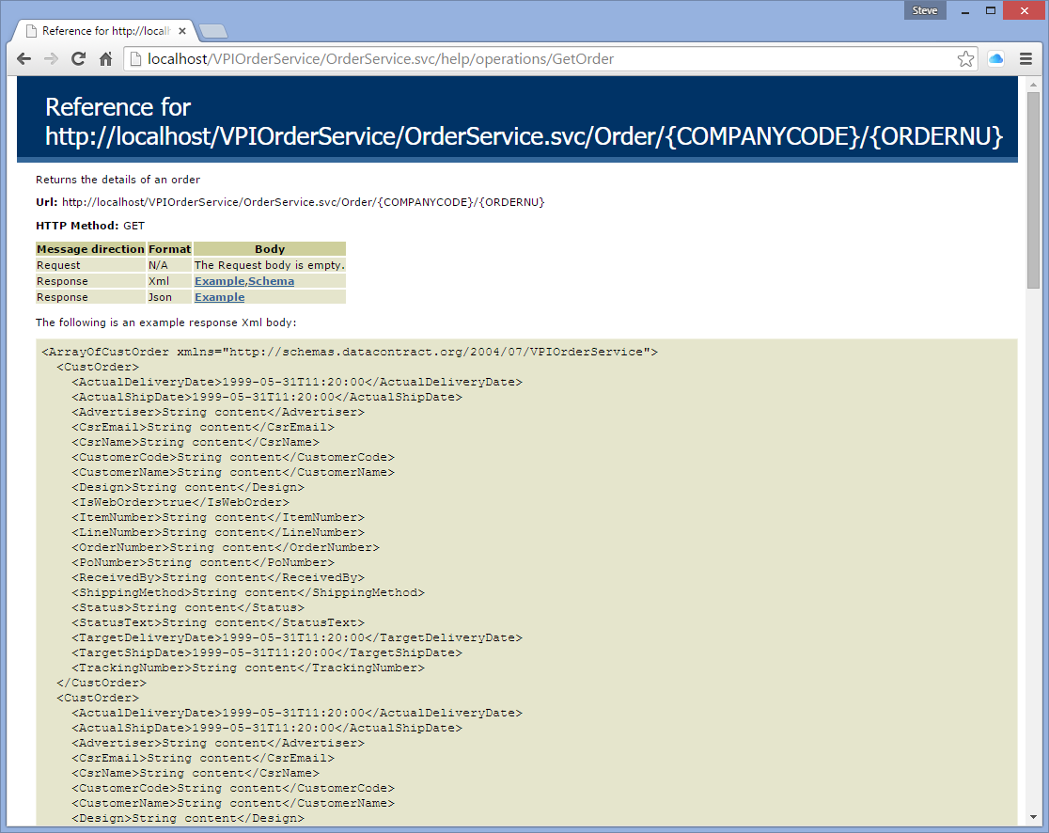

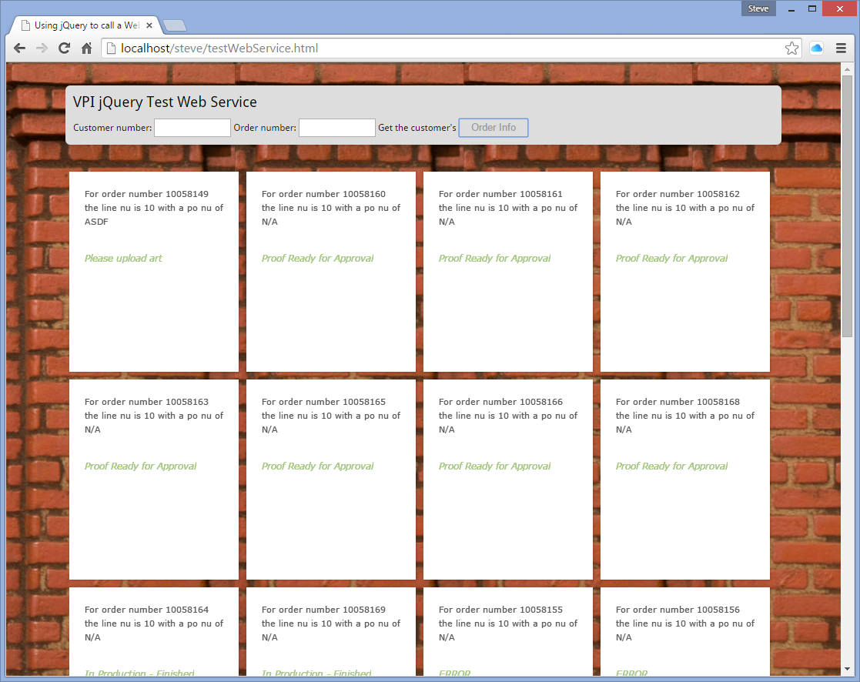

The above is a jQuery example of calling the service.

$('#butOrder').click(function(){

//alert('In event');

if ($("#custno").val() == "")

{

var resultsField = document.getElementById("inner-container");

resultsField.innerHTML = "";

$("#inner-container").append('<P>Customer is a required field for the service.</p>');

}

else

{

if($("#orderno").val() == "")

SerTail = $("#custno").val();

else

SerTail = "Order/" + $("#custno").val() + "/" + $("#orderno").val();

//alert('url ' + Servurl+SerTail);

jQuery("body").css("cursor", "progress");

$.ajax({

type: "GET",

url: Servurl+SerTail,

dataType: "xml",

success: callback,

error: function(){

alert("Error attempting to contact service.");

jQuery("body").css("cursor", "default");

}

});

}

});

To call the service you can create a MS console application with the following code.

/// <summary>

/// Call the service using the http req technique

/// </summary>

[Conditional("callReq")]

private static void callMyServiceReq()

{

Console.WriteLine("In ServiceReq");

Console.WriteLine("Call retrieve orders");

string uri = "http://localhost/VPIOrderService/OrderService.svc/C00001";

HttpWebRequest Ordersrequest = (HttpWebRequest)HttpWebRequest.Create(uri);

Ordersrequest.Method = "GET";

using (HttpWebResponse response = (HttpWebResponse)Ordersrequest.GetResponse())

{

System.Xml.XmlDocument doc = new System.Xml.XmlDocument();

doc.Load(response.GetResponseStream());

XmlNodeList theOrders = doc.GetElementsByTagName("CustOrder");

List<CustOrder> myorders = GetMyOrders(theOrders);

foreach(CustOrder theOrder in myorders)

{

Console.WriteLine("order = {0} line = {1} status = {2}",

theOrder.OrderNumber, theOrder.LineNumber, theOrder.StatusText);

}

}

Console.WriteLine("");

Console.WriteLine("Call retrieve orders");

uri = "http://localhost/VPIOrderService/OrderService.svc/Order/C00001/10058164";

HttpWebRequest Orderrequest = (HttpWebRequest)HttpWebRequest.Create(uri);

Orderrequest.Method = "GET";

using (HttpWebResponse response = (HttpWebResponse)Orderrequest.GetResponse())

{

System.Xml.XmlDocument doc = new System.Xml.XmlDocument();

doc.Load(response.GetResponseStream());

//List<CustOrder> theOrders = GetMyPro(doc);

XmlNodeList theOrders = doc.GetElementsByTagName("CustOrder");

List<CustOrder> myorders = GetMyOrders(theOrders);

foreach (CustOrder theOrder in myorders)

{

Console.WriteLine("order = {0} line = {1} status = {2}",

theOrder.OrderNumber, theOrder.LineNumber, theOrder.StatusText);

}

}

Console.WriteLine("Leaving ServiceReq");

}

private static List<CustOrder> GetMyOrders(XmlNodeList theOrders)

{

List<CustOrder> theObjs = new List<CustOrder>();

foreach (XmlNode node in theOrders)

{

CustOrder theObj = new CustOrder();

//Use the reflection to get all the properties of this class object and set those

System.Reflection.PropertyInfo[] arrPropInfo = theObj.GetType().GetProperties();

for (int i = 0; i < arrPropInfo.Length; i++)

{

string xmlname = arrPropInfo[i].Name;

System.Reflection.PropertyInfo propInfo = arrPropInfo[i];

String xmlValue = node[xmlname].InnerText;

Object typeCastedValue = xmlValue;

switch (propInfo.PropertyType.Name)

{

case "Boolean":

typeCastedValue = xmlValue.Equals("true") ? true : false;

break;

case "Int32":

typeCastedValue = Convert.ToInt32(xmlValue);

break;

case "DateTime":

typeCastedValue = Convert.ToDateTime(xmlValue);

break;

}

propInfo.SetValue(theObj, typeCastedValue, null);

}

theObjs.Add(theObj);

theObj = null;

}

return theObjs;

}

